Excel 2007

Setting up your workspace and worksheet

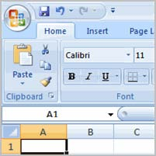

Before you begin creating spreadsheets in Excel, you may want to **set up your Excel environment** and become familiar with a few **key tasks and features** such as how to minimize and maximize the Ribbon, configure the Quick Access toolbar, switch page views, and access your Excel options.

**Exploring and Setting Up Your Excel Environment**

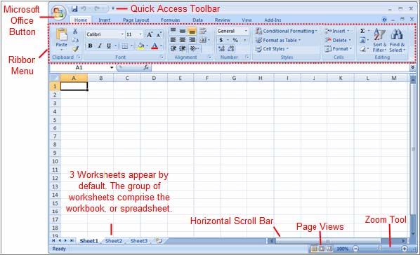**Exploring the Excel Environment**

The **tabbed Ribbon menu system** is how you navigate through Excel and access the various Excel commands. If you have used previous versions of Excel, the Ribbon system replaces the traditional menus. Above the Ribbon in the upper-left corner is the **Microsoft Office Button**. From here, you can access important options such as New, Save, Save As, and Print. By default the **Quick Access Toolbar** is pinned next to the Microsoft Office Button, and includes commands such as Undo and Redo.

At the bottom, left area of the spreadsheet, you will find worksheet tabs. By default, **three worksheet tabs** appear each time you create a new workbook. On the bottom, right area of the spreadsheet you will find page view commands, the zoom tool, and the horizontal scrolling bar.

**To Zoom In and Out:**

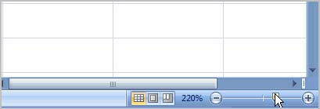 Locate the **zoom bar** in the bottom, right corner.

Left-click the **slider** and **drag** it to the left to zoom in and to the right to zoom out.

**To Scroll Horizontally in a Worksheet:**

Locate the **horizontal scroll bar** in the bottom, right corner.

Left-click the bar and move it from left to right.

**To Change Page Views:**

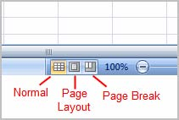 Locate the **Page View options** in the bottom, right corner. The Page View options are Normal, Page Layout, and Page Break.

Left-click an option to select it.

The default is **Normal View**.

**To Add Commands to the Quick Access Toolbar:**

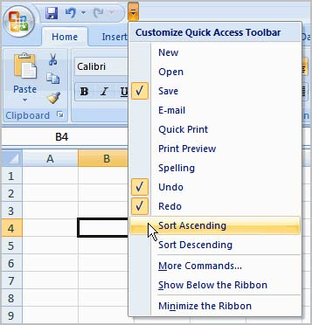

Click the **arrow** to the right of the Quick Access toolbar.

Select the **command** you wish to add from the drop-down ist. It will appear in the Quick Access OR

Select **More Commands** from the menu and a dialog box appears.

Select the command you wish to add.

Click the **Add** button. Click **OK**.

The Save, Undo, and Redo commands appear by default in the Quick Access toolbar. You may wish to add other commands to make using specific Excel features more convenient for you.

.

**To Minimize and Maximize the Ribbon:**

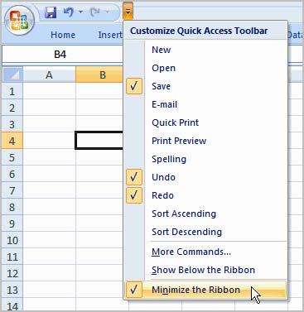Click the **drop-down arrow** next to the Quick Access toolbar.

1. Select **Minimize Ribbon** from the list. The Ribbon disappears.
2. To maximize the ribbon, click the arrow again and select **Minimize the Ribbon** to toggle the feature off.

You can also minimize and maximize the Ribbon by right-clicking anywhere in the main menu and

selecting **Minimize the Ribbon** in the menu that appears.

The new, **tabbed Ribbon system** replaces traditional menus in Excel 2007. It is designed to be responsive to your current task and easy to use; however, you can choose to **minimize the Ribbon** if you would prefer to use different menus or keyboard shortcuts.

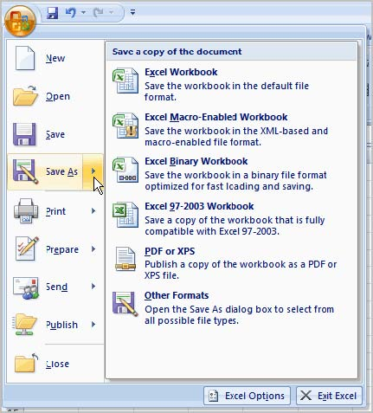

**The Microsoft Office Button**

The **Microsoft Office Button** appears at the top of the Excel window. When you left-click the button, a menu appears. From this menu you can create a new spreadsheet, open existing files, save files in a variety of ways, and print. You can also add security features, send, publish, and close files.

**To Change the Default Excel Options:**

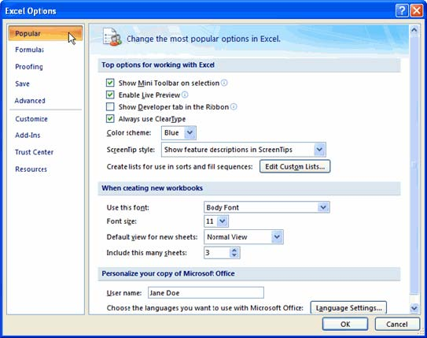 Click the **Excel Options** button. A dialog box will appear.

1. Select a **category** on the left to access different Excel options.
2. Modify any of the default settings.
3. Click OK.

As you learn more about Excel and become proficient at using it, you may want to modify some of the settings. As a **beginning user**, it is usually best to **leave** the **default settings**.

**Your First Workbook**

You will need to know how to **insert text** and **numbers** into Excel workbooks to be able to use it to calculate, analyze, and organize data. In this lesson, you will learn how to create a new workbook, insert and delete text, navigate a worksheet, and save an Excel workbook.

**To Create a New, Blank Workbook:**

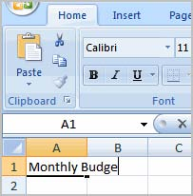

Left-click the **Microsoft Office Button**.

Select **New**. The New Workbook dialog box opens and Blank Workbook is highlighted by default.

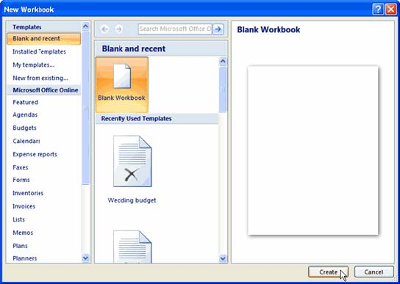

Click **Create**. A new, blank workbook appears in the window.

When you first open Excel, the software opens to a new, blank workbook.

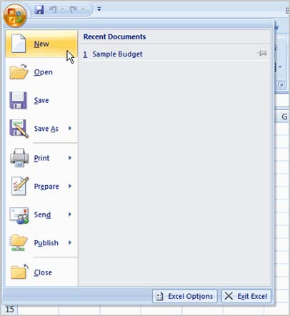

**To Insert Text:**

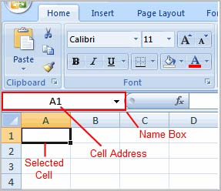 Left-click a **cell** to select it. Each **rectangle** in the worksheet is called a **cell**. As you select a cell, the **cell address** appears in the **Name Box**.

Enter **text** into the **cell** using your keyboard. The text appears in the cell and in the **formula bar**.

Each cell has a name, or a **cell address** based on the **column** and **row** it is in. For example, this cell is C3 since it is where column C and row 3 intersect.

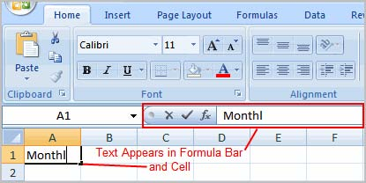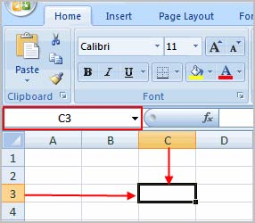

**To Edit or Delete Text:**

1. Select the cell.
2. Press the **Backspace** key on your keyboard to delete text and make a correction.
3. Press the **Delete** key to delete the entire contents of a cell.

You can also make changes to and delete text from the **formula bar**. Just select the cell and place your insertion point in the formula bar.

**To Move Through a Worksheet Using the Keyboard:**

Press the **Tab** key to move to the **right** of the selected cell.

1. Press the **Shift** key and then the **Tab** key to move to the **left** of the selected cell.
2. Use the **Page Up** and **Page Down** keys to navigate the worksheet.
3. Use the arrow keys.

**To Save the Workbook:**

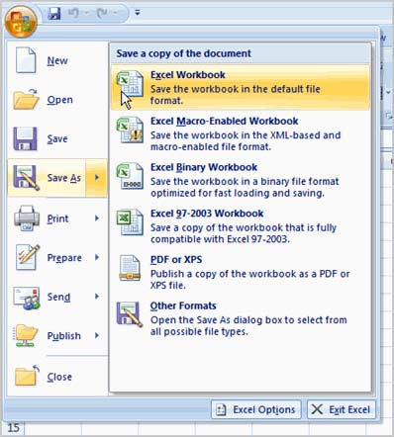

Left-click the **Microsoft Office Button**.

Select **Save** or **Save As**.

**Save As** allows you to name the file and choose a location to save the spreadsheet. Choose **Save As** if you'd like to save the file for the **first** time or if you'd like to save the file as a different name.

1. Select **Save** if the file has already been named.

You can save a workbook in many ways, but the two most common are as an **Excel Workbook**, which saves it with a 2007 file extension, and as an **Excel 97-2003 Workbook**, which saves the file in a compatible format so people who have earlier versions of Excel can open the file.

**Modifying Columns, Rows, and Cells**

When you open a new, blank workbook, the cells, columns, and rows are set to a **default size**. You do have the ability to change the size of each, and to insert new columns, rows, and cells, as needed. In this lesson, you will learn various methods to modify the column width and row height, in addition to how to insert new columns, rows, and cells.

**Columns, Rows, and Cells**

**To Modify Column Width:**

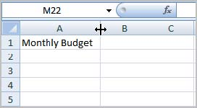Position the **cursor** over the **column line** in the column heading and a **double arrow** will appear. Left-click the mouse and **drag** the cursor to the **right** to **increase** the column width or to the **left** to **decrease** the column width.

**Release** the mouse button.

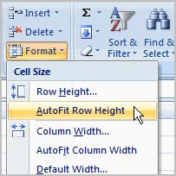**OR**

Left-click the **column heading** of a column you'd like to modify. The entire column will appear **highlighted**.

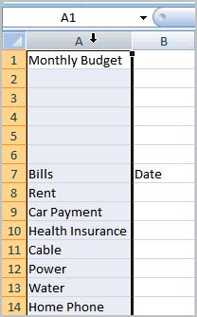Click the **Format** command in the Cells group on the **Home** tab. A menu will appear.

Select **Column Width** to enter a **specific** column **measurement**.

Select **AutoFit Column Width** to adjust the column so all the text will fit.

**To Modify the Row Height:**

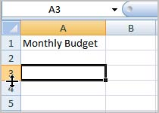 Position the **cursor** over the **row line** you want to modify and a **double arrow** will appear.

Left-click the mouse and **drag** the cursor **upward** to **decrease** the row height or **downward** to **increase** the row height.

**Release** the mouse button.

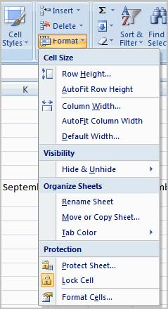**OR**

Click the **Format** command in the Cells group on the **Home** tab. A menu will appear.

1. Select **Row Height** to enter a **specific** row **measurement**.

Select **AutoFit Row Height** to adjust the row so all the text will fit.

**To Insert Rows:**

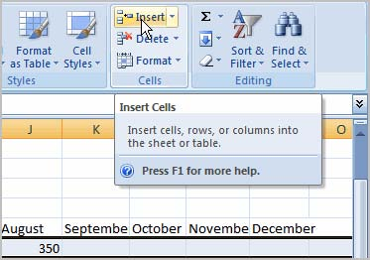 Select the row **below** where you want the new row to appear.

Click the **Insert** command in the Cells group on the Home tab. The row will appear.

The new row always appears above the selected row.

Make sure that you select the **entire row** below where you want the new row to appear and **not** just the **cell**. If you select just the cell and then click Insert, only a new cell will appear.

**To Insert Columns:**

1. Select the column to the right of where you want the column to appear.
2. Click the **Insert** command in the Cells group on the Home tab. The column will appear.

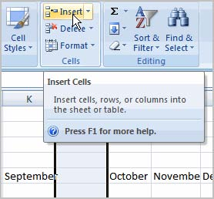

The new column always appears to the left of the selected column. For example, if you want to insert a column between September and October, select the October column and click the Insert command.

Make sure that you select the **entire column** to the right of where you want the new column to appear and **not** just the **cell**. If you select just the cell and then click Insert, only a new cell will appear.

**To Delete Rows and Columns:**

Select the row or column you’d like to delete.

Click the Delete command in the Cells group on the Home tab.

**Formatting Tables**

**Introduction**

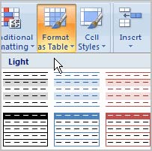Once you have entered information into a spreadsheet, you may want to **format** it. Formatting your spreadsheet can not only make it look nicer, but make it easier to use. In a previous lesson we discussed many manual formatting options such as bold and italics. In this lesson, you will learn how to use the **predefined tables styles** in Excel 2007 and some of the **Table Tools** on the Design tab

**To Format Information as a Table:**

1. Select any cell that contains information.
2. 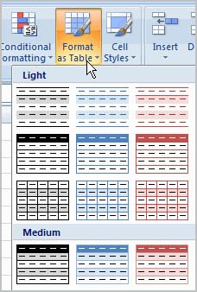Click the **Format as Table** command in the **Styles** group on the Home tab. A list of predefined tables will appear.

Left-click a **table style** to select it.

1. A dialog box will appear. Excel has **automatically selected the cells** for your table. The cells will appear selected in the spreadsheet and the range will appear in the dialog box.
2. 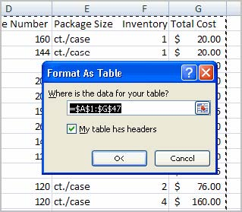Change the **range** listed in the field, if necessary.
3. Verify the box is selected to indicate your table has **headings**, if it does. Deselect this box if your table does not have column headings.
4. Click OK. The table will appear formatted in the style you chose.

By default, the table will be set up with the **drop-down arrows in the header** so that you can filter the table, if you wish. In addition to using the **Format as Table** command, you can also select the **Insert** tab, and click

the **Table** command to insert a table.

**To Modify a Table:**

Select **any cell** in the table. The Table Tools Design tab will become active. From here you can modify the table in many ways.

You can:

Select a **different table** in the **Table Styles Options** group. Click the **More** drop-down arrow to see more table styles.

Delete or add a **Header Row** in the Table Styles Options group.

1. Insert a **Total Row** in the Table Styles Options group.
2. Remove or add **banded rows or columns**.
3. Make the first and last columns **bold**.
4. **Name** your table in the Properties group.
5. Change the cells that make up the table by clicking **Resize Table**.

When you apply a table style, filtering arrows automatically appear. To **turn off filtering**, select the Home tab, click the **Sort & Filter** command, and select **Filter** from the list.

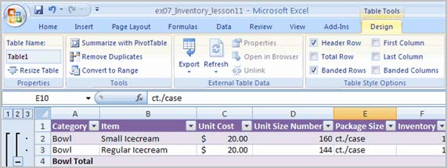

**Simple Formulas**

**To Create a Simple Formula that Adds Two Numbers:**

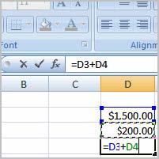

1. Click the cell where the formula will be defined (C5, for example).
2. Type the equal sign (=) to let Excel know a formula is being defined.
3. Type the first number to be added (e.g., 1500)
4. Type the **addition sign (+)** to let Excel know that an add operation is to be performed.
5. Type the second number to be added (e.g., 200)
6. Press **Enter** or click the **Enter button** on the Formula bar to complete the formula.

Excel can be used to **calculate** and **analyze** numerical information; however, you will need to know how to write **formulas** to maximize Excel's capabilities. A formula is an equation that performs a calculation using values in the worksheet. In this lesson you will learn how to **create simple formulas** using mathematical operators such as the addition, subtraction, multiplication, and division signs.

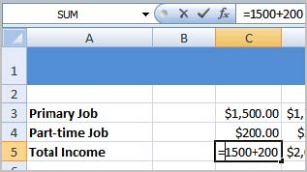

**To Create a Simple Formula that Adds the Contents of Two Cells:**

1. Click the cell where the answer will appear (C5, for example).
2. 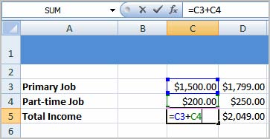Type the equal sign (=) to let Excel know a formula is being defined.
3. Type the cell number that contains the first number to be added (C3, for example).
4. Type the **addition sign (+)** to let Excel know that an add operation is to be performed.
5. Type the cell address that contains the second number to be added (C4, for example).
6. Press **Enter** or click the **Enter button** on the Formula bar to complete the formula.

**To Create a Simple Formula using the Point and Click Method:**

1. Click the cell where the answer will appear (C30, for example).
2. Type the equal sign (=) to let Excel know a formula is being defined.
3. Click on the **first cell** to be included in the formula (C5, for example).
4. Type the **subtraction sign (-)** to let Excel know that a subtraction operation is to be performed.

Click on the **next cell** in the formula (C29, for example).

Press **Enter** or click the **Enter button** on the Formula bar to complete the formuls.

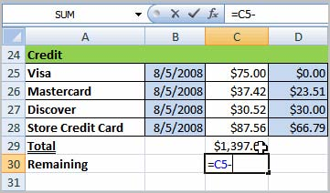

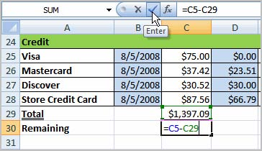

**To Create a Simple Formula that Multiplies the Contents of Two Cells**:

Select the cell where the answer will appear (E32, for example).

Type the equal sigh (=) to let Excel know a formula is being defined.

Click on the **first** **cell** to be included in the formula C-9, for example) or type a number.

Type the multiplication symbol (*)by pressing the Shift key and then the number 8 key.

The operator displays in the cell and Formula bar.

Click the **next cell.**

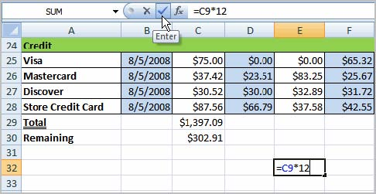

**To Create a Simple Formula that Divides One Cell by Another:**

1. 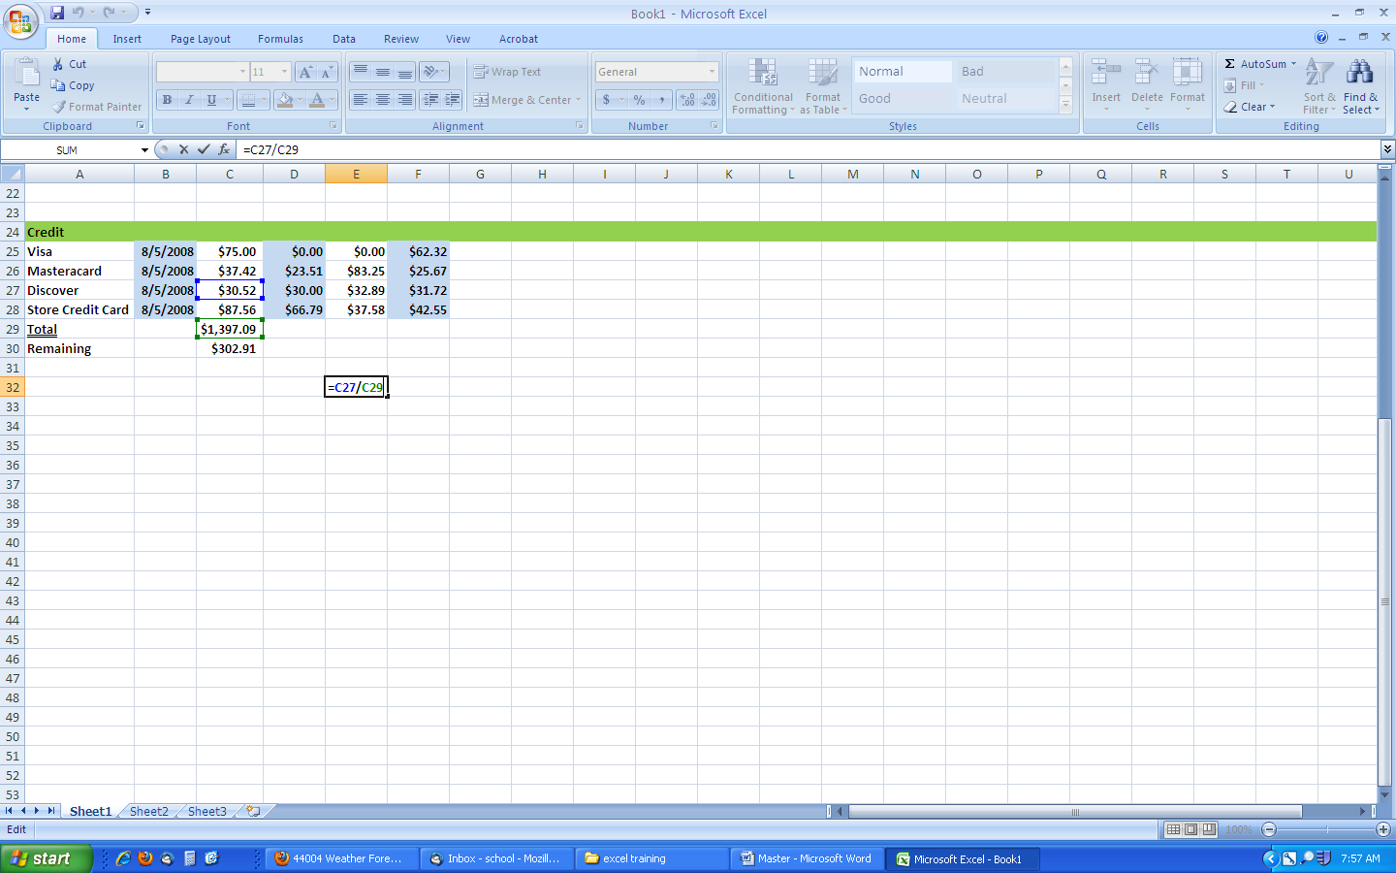Click the cell where the answer will appear.
2. Type the equal sign (=) to let Excel know a formula is being defined.
3. Click on the **first cell** to be included in the formula.
4. Type a division symbol (/). The operator displays in the cell and Formula bar.
5. Click on the **next cell** in the formula.
6. **Enter** or click the **Enter button** on the Formula bar to complete the formula.

**Using Cell References**

As you can see, there are many ways to create a simple formula in Excel. Most likely you will choose one of the methods that enter the cell address into the formula, rather than an actual number. The cell address is basically the name of the cell and can be found in the Name Box.

The following example uses actual numbers in the formula in C5. When a cell address is used as part of a formula, this is called a **cell reference**. It is called a **cell reference** because instead of entering specific numbers into a formula, the cell address refers to a specific cell. The following example uses cell references in the formula in C30.

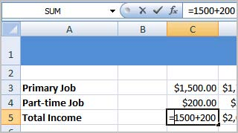

Actual Number



Cell Address or Cell Reference